**The Effect of Poverty Rates on Opioid Mortality**

Jack Kissell

**Abstract**

The opioid abuse crisis is among the most significant medical issues in the United States. As some previous literature has hypothesized, poverty may be a predictor of increased likelihood of opioid mortality. Therefore, this study uses 2017 state-level data to test the effect of poverty rates on state opioid mortality, controlling for other potential factors like insurance, region, and race. The results show that when a state’s poverty rate increases by 1%, opioid mortality increases by about 3.6 deaths per 100,000 (p-value <0.05). after running further tests to correct for errors in the residuals, we can conclude that poverty rates do effect state opioid mortality, and that funding should be increased for opioid abuse treatment in impoverished areas to hopefully counteract this effect.

**Introduction**

The United States has witnessed a dramatic increase in opioid abuse and mortality in the past two decades, making the opioid crisis among the most significant medical crises in recent history. Fatal drug overdose rates saw a 250% increase in the US between 1999 and 2017, and opioid abuse has contributed significantly to this increase, accounting for over 47,000 deaths in 2017 alone (Monnat et al 2019). Mortality has not been the only result of the crisis, however, as an estimated 1.7 million people suffered from substance abuse disorders relating to the use of prescription opioid pain relievers in 2017, and over 20% of the people prescribed opioids for chronic pain misused them (NIDA). The economic burden of the opioid crisis is another significant dimension of its damage, with the CDC estimating that the costs of opioid abuse in the US total about $75.8 billion per year in healthcare, addiction treatment, lost productivity, and criminal justice involvement (NIDA). Despite these significant social and economic costs, methods of government intervention in the crisis have been limited and have not seen significant improvement.

While the epidemic of opioid abuse and mortality has swept across the country, it has not evenly affected the population. Previous literature has suggested that, at an individual level, various risk factors are more likely to be present in the population suffering from opioid abuse, with the most vulnerable population being white males who are either uninsured or on Medicare; regional and geographic variations also exist (KFF). As previous research has suggested that poverty is a significant risk factor for other types of drug abuse, it has been hypothesized that poverty can also be observed as a predictor of opioid abuse. Therefore, conducting an examination into the potential correlation between poverty rates and rates of opioid abuse at a state or regional level could be a potential avenue for further understanding of, and prevention methods for, the opioid mortality epidemic. This research paper will attempt to add to previous literature by examining the effect of state poverty rates on opioid mortality, with controls implemented for other risk factors, in order to shed further light on the trend. It will also conclude by discussing potential policy implications of the findings.

**Literature Review**

Given that the opioid crisis is among the most significant medical epidemics in the US, there exists a fairly expansive body of literature on the subject. However, as with other important medical trends, further updated research is always required to account for new developments and changes in the data.

Among the earlier investigations into this subject is a review by Spiller et al in 2009, conducted before the most significant boom in opioid mortality between 2009 and 2017. This investigation observed a consistent positive trend between rates of poverty and unemployment and rates of opioid abuse and misuse. However, the observations were obtained using data from 2003-2006, and as such further analysis using updated data is required to conclude if the observed trend has continued.

Further observations using data at the county and community level have observed a strong association between poverty levels and opioid abuse, holding constant other relevant variables. In an extensive review on the subject, Ghertner and Groves (2018) conducted a regression analysis using county-level data and concluded that overall there was a strong statistical link between measures of economic opportunity (unemployment, poverty) and measures of the opioid crisis (mortality, hospitalizations, and prescription rates). Additionally, Ghertner and Groves observed that these findings varied given geographic and regional influences, with certain regions having a higher degree of correlation (2018). They hypothesize that areas of economic disparity lack adequate funding for support services, while also being directly impacted by increasing rates of opioid prescription.

Similar findings are obtained by Monnat et al, who conducted empirical analysis of economic factors and opioid mortality, again at the county level. Like Ghertner and Groves, Monnat et al witness higher rates of death from prescription opioids, as well as combinations of prescription and synthetic opioids, in more economically disadvantaged counties (2019). They also observe degrees of variation by region as well as industry of work.

Finally, Singh et al (2019) examine trends in opioid mortality by race, age, geographic area, and measures of economic advantage. They conclude that race plays a role in opioid mortality, observing the highest rates among non-Hispanic whites, and that regional variables are also correlates, with the New England and Mid-Atlantic regions experiencing the highest mortality rates and largest degree of mortality increase between 2009 and 2017 (Singh et al 2019). They further conclude that lack of economic opportunities was also a contributing factor to opioid abuse rates among these populations.

**Empirical Model**

Multivariate linear regression will be used to conduct the analysis. The model will test the hypothesis that state poverty rates are positively correlated with rates of opioid mortality, against the null that there is no correlation. The model used is as follows:

*Opioid dr = α + β1povertyrate + β2uninsured + β3interaction +β4prescription rate +β5region +β6race + u*

The dependent variable of interest, *opioid dr*, measures state opioid death rates. The independent variable of interest, *povertyrate*, measures the proportion of the population living below the federal poverty line.

*Uninsured* measures the proportion of the population which does not have insurance; this variable is controlled for as research has shown that those who are uninsured are at greater risk of opioid mortality (KFF). In order to prevent potential multicollinearity, an interaction variable was added for the variables *uninsured* and *povertyrate;* this variable was defined as the product of the uninsured proportion and poverty rate by state (*interaction* = *povertyrate*\**uninsured*). An additional control is implemented for the rate of opioid prescriptions by state (as measured by the number of prescriptions per 100 population). Finally, the model controls for state racial demographics (white is excluded) and regional characteristics (northeast is excluded).

**Data**

All data is from 2017, as it was the most recent year that comprehensive data existed for all variables in every state. As opioid abuse can be difficult to quantify, this study chooses to measure it by the rate of opioid mortality per state, measured by the number of opioid-related deaths per 100,000 population; data for this variable is obtained from the Kaiser Family Foundation. Among the various measures of economic disparity by state, state poverty rates were chosen for the purpose of this study; poverty rate data is also provided by the KFF.

Data for the proportion of state population which is either uninsured or on welfare is also provided by KFF, along with state racial demographics. State opioid prescription rate data is provided by the National Institute of Health’s Institute on Drug Abuse.

Table 1 below presents descriptive statistics.

Table 1. Descriptive Statistics

|  |  |  |  |
| --- | --- | --- | --- |
| **Variable** | **Mean**  **(St. Deviation)** | **Min** | **Max** |
| Opioid Death Rate | 16.26  (10.52) | 3.1 | 49.6 |
| Poverty Rate | 10.82  (2.79) | 5 | 17 |
| Uninsured | 8.16  (3.01) | 3 | 17 |
| Interaction (povertyrate*uninsured) | 90.59  (45.68) | 24 | 221 |
| Prescription rate | 62.32  (17.65) | 28.5 | 107.2 |
| Black | 11.00  (10.61) | 0.4 | 45.3 |
| Hispanic | 11.87  (10.32) | 1.3 | 48.8 |
| Asian | 4.24  (5.45) | 0.7 | 38.3 |

As previous literature has suggested, the data shows a wide variance of opioid mortality across states. The highest mortality rate is 49.6 per 100,000 in West Virginia, and the lowest is 3.1 per 100,000 in Nebraska. The average value is about 16.26 per 100 thousand. Poverty rate is also varied by state, although the degree of variation is not as pronounced. The lowest poverty rate is 5% of the population, observed in New Hampshire; the highest rate is 17%, in Mississippi, West Virginia, and New Mexico. The average poverty rate per state is about 10.82%.

**Empirical Results**

Regression results show that state poverty rates can be observed as a determinant of opioid mortality. States with higher levels of poverty also display higher rates of opioid abuse. When a state’s poverty rate increases by 1%, opioid mortality increases by about 3.6 deaths per 100,000 (p-value <0.05).

Table 2: Empirical Results

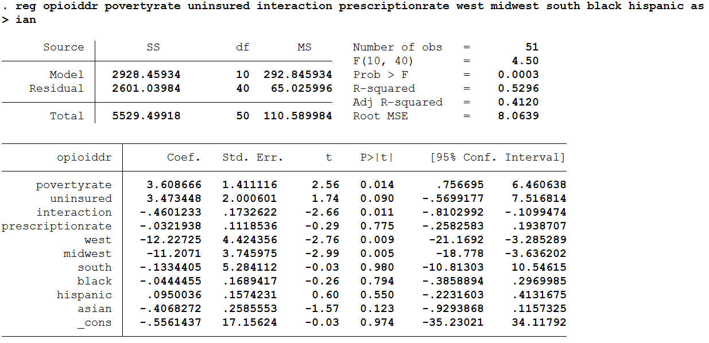

Being uninsured has been observed by previous research as a significant risk factor for opioid abuse and mortality. Therefore, it is important to control for this variable to prevent omitted variable bias. However, it could conceivably argued that living in poverty makes one more likely to be uninsured. As poverty rates increase, the population of uninsured people likely also increases, and as increases in uninsured population have been shown to increase opioid mortality, the study cannot determine whether an increase in opioid mortality is caused by poverty or being uninsured. Therefore, to prevent potential bias from this correlation of independent variables, an interaction variable was used to isolate the effect of *uninsured* from the effect of *povertyrate*. As was theorized, the results show that the correlation between being uninsured and opioid mortality is positive and statistically significant (p-value <0.1). The interaction of poverty and uninsured is also statistically significant (p-value <0.05). However, independent of the effect of being uninsured, state poverty rate is still correlated with opioid mortality at a statistically significant level.

Additionally, as argued by the results of the studies presented in the literature review, regional variables are correlated with opioid mortality, with the Midwest and Western regions having lower rates of opioid mortality than Northeastern states (p-values <0.01).

**Further Tests**

Prior to this point in the study, several important assumptions of errors in the residuals have been made which allowed for the regression to be run. These assumptions are homoscedasticity, normal residuals, no multicollinearity, and no autocorrelation (which would be indicative of omitted variables). However, it is important to run further diagnostic tests on the model in order to determine whether it suffers from any of these issues, and if so, how they can be corrected for in order to obtain more reliable results.

**Breusch-Pagan Test for Heteroskedasticity**

The model assumes homoscedasticity, meaning that the variables are assumed to be evenly distributed. If this assumption is violated, the residuals are unevenly spread and heteroskedastic, and the variances are underestimated, making the OLS estimators inefficient. To test for heteroskedasticity, a Breusch-Pagan test was performed, the results of which are shown below.

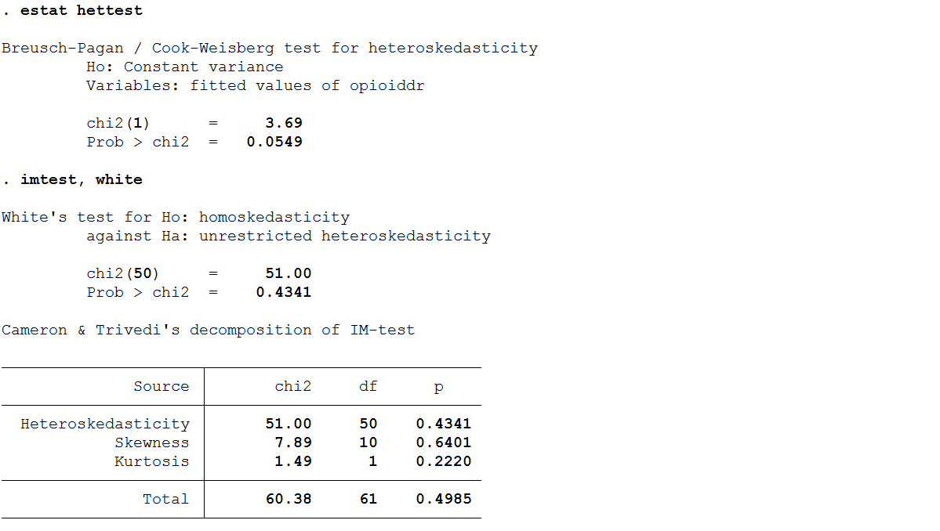

The Breusch-Pagan test tests against the null that the variance is constant, and the results provide a significant chi-squared variable, allowing for the null to be rejected and indicating that the model likely suffers from heteroskedasticity which must be corrected for in future regressions.

**VIF Test for Multicollinearity**

The second assumption to be tested is multicollinearity. If a linear relationship exists between any of the independent variables, the coefficients can become unstable and their standard errors will be inflated. A Variance Inflation Test was performed to test for this condition.

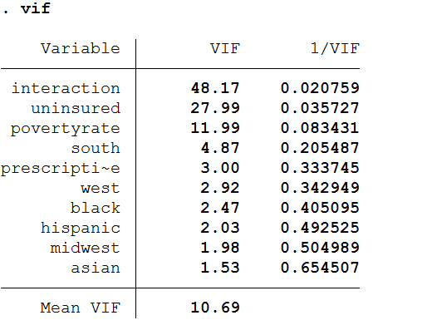

Generally, a VIF variable greater than 10 is assumed to be indicative of multicollinearity. These results therefore back up the hypothesis made earlier that a linear relationship likely exists between the *uninsured* and *povertyrate* variables, as both have a VIF over 10. The interaction variable was created and added to the model to control for the effect of this multicollinearity. However, continued refinement to the model is certainly possible to further reduce any additional impacts of this multicollinearity.

**Skewness-Kurtosis Test for Normality**

The next assumption made by the model is that the data are approximately normally distributed. It is important to test for this condition as normality allows for valid hypothesis testing by ensuring that the p-values and F-test are valid. To test for normality, a Skewness-Kurtosis test was performed and its results are provided below.

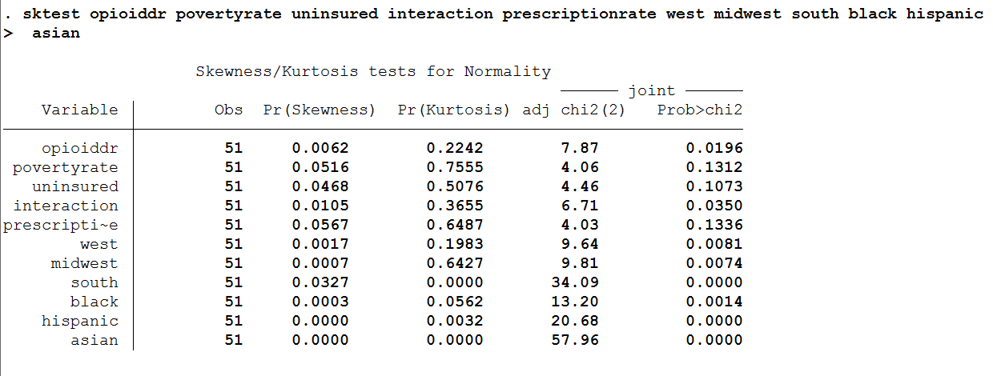

The results of this test show that the model suffers from skewness and the distribution is not normal. Therefore, changes must be made to correct for this problem in future regressions.

**Ramsey Test**

The final diagnostic test performed was a Ramsey test, which can help determine autocorrelation by detecting potential omitted variable bias. The Ramsey test tests whether non-linear combination of the fitted values help explain the dependent variable, and if they do this may indicate that the model is improperly specified.



The results of this test show an insignificant F-value, indicating that the model passes the Ramsey RESET test and is adequate.

The primary errors shown by the diagnostic tests were heteroskedasticity and non-normal distribution. In order to correct for these errors, an additional regression was run using the log of the dependent variable, *opioiddr*, which is notated as *lopioid*. Additionally, robust standard errors were used to further correct for the impact of heteroskedasticity.

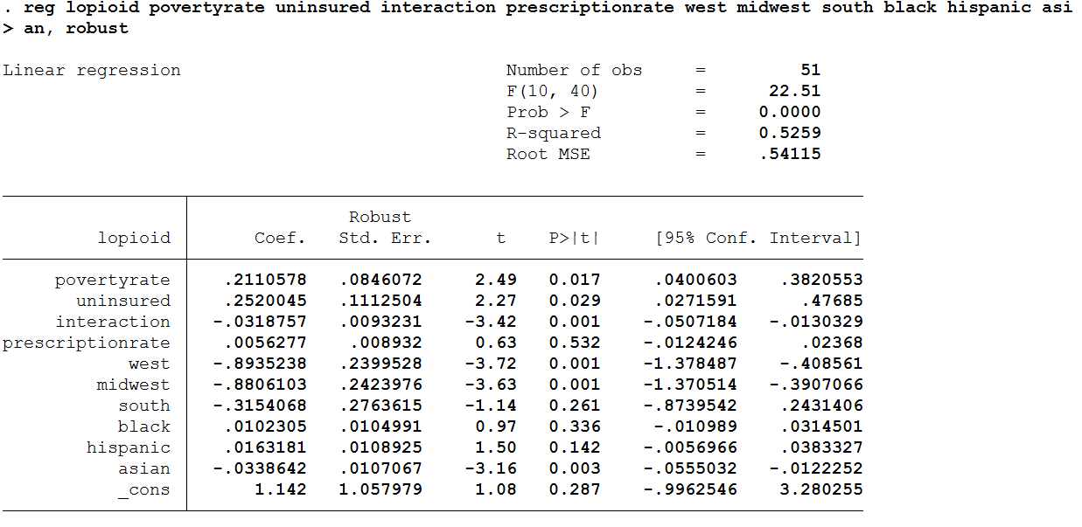

**Conclusions and Policy Implications**

The empirical results of this study show that state opioid death rates increase corresponding with an increase in poverty rate, even after controlling for the effect of being uninsured. The findings of this paper suggest that state governments and public health officials should consider targeting impoverished communities in order to reduce the trend of opioid mortality. As previous literature has suggested, a potential cause of the correlation between poverty and opioid mortality is the lack of adequate funding for support services in impoverished and high-risk communities; this is certainly an issue that needs to be addressed. Luckily, some action has been taken with this goal in mind; the Centers for Medicare Services has encouraged states to expand treatment for opioid misuse disorder for Medicare recipients, and in 2018 funding was increased to the Health Resources and Services Administration to improve addiction treatment in rural and underserved areas (Ghertner & Groves, 2018). This paper adds to the growing evidence that such actions should be a more important focus of future policies aimed at further reducing the impact of the opioid crisis in the United States.

There are potential limitations with the findings presented in this paper. Mainly, it is possible that potential errors in the reporting or diagnosing of opioid mortality may be over or understating the frequency of its occurrence at the state level. Additionally, while opioid mortality was chosen for the purpose of this study, there is no way to exactly quantify or measure opioid abuse, and thus stand-ins such as mortality or opioid-related hospitalizations are frequently used to represent opioid abuse, but they may not accurately reflect the trend of opioid abuse in the US. While diagnostic tests and an additional regression were run to improve the model, it is certainly possible that further unseen problems exist which may limit the significance of the findings.

Works Cited

Ghertner R, Groves L. 2018. The Opioid Crisis and Economic Opportunity: Geographic and Economic Trends. *ASPE Research Brief*.

Kaiser Family Foundation, 2017. Opioid Overdose Data. Available at <https://www.kff.org/state-category/health-status/opioids/>

Kaiser Family Foundation, 2017. State Poverty Data. Available at <https://www.kff.org/state-category/demographics-and-the-economy/people-in-poverty/>

Kaiser Family Foundation, 2017. State Racial Demographic Data. Available at <https://www.kff.org/state-category/demographics-and-the-economy/population/>

Kaiser Family Foundation, 2017. State Insurance Data. Available at <https://www.kff.org/state-category/health-coverage-uninsured/>

Monnat SM, Peters DJ, Berg MT, Hochstetler A. Using Census Data to Understand County-Level Differences in Overall Drug Mortality and Opioid-Related Mortality by Opioid Type. *American Journal of Public Health*. 2019;109(8):1084-1091.

National Institute on Drug Abuse. (2019, January 22). Opioid Overdose Crisis. Retrieved from <https://www.drugabuse.gov/drugs-abuse/opioids/opioid-overdose-crisis>.

National Institute on Drug Abuse (NIDA), 2017. Opioid Prescription Rate Data. Available at <https://www.drugabuse.gov/drugs-abuse/opioids/opioid-summaries-by-state>

Orgera, K., & Tolbert, J. (2019, July 16). Key Facts about Uninsured Adults with Opioid Use Disorder. Retrieved from <https://www.kff.org/uninsured/issue-brief/key-facts-about-uninsured-adults-with-opioid-use-disorder/>.

Singh, et al. 2019. Opioid Epidemic in the United States: Empirical Trends, and A Literature Review of Social Determinants and Epidemiological, Pain Management, and Treatment Patterns*. International Journal of Maternal and Child Health and AIDS (2019)*, Volume 8, Issue 2, 89-100.

Spiller et al. 2009. Epidemiological Trends in Abuse and Misuse of Prescription Opioids, *Journal of Addictive Diseases*, 28:2, 130-136